Allocation of 2 Intensive Care Area beds in the Ursula Frayne Centre to clients of the Orygen Inpatient Unit, Mavis Street, Footscray

CHANGE IMPACT STATEMENT
- Background
Due to renovation and redevelopment work the Orygen Inpatient Unit (OIPU) have closed their two (2) Intensive Care Area (ICA) beds. The Department of Health and Human Services (DHHS) have requested that Mercy Mental Health (MMH) allocate two (2) ICA beds in the Ursula Frayne Centre (UFC) for the use of clients of the IPU also sited at Mavis St Footscray. It is planned that this allocation takes effect from 13 January 2020 and the redevelopment of the OIPU is planned to be completed at the end of June 2020.
- Proposed Change
That 2 ICA beds within UFC be allocated for the use of the OIPU. It is important to note that;
- the category of client utilising these beds will be unchanged, including age range, as MMH have always provided care for young people over the age of 18 years who are eligible for OIPU admissions. This is because there are more young people in our catchment area that require OIPU admissions than the beds available in OIPU
- clinical governance for clients in MMH beds will rest with MMH. This is also unchanged as MMH already provide care for young people over the age of 18 years who are eligible for OIPU admissions.

An MoU between MMH and North Western Area Mental Health Service (AMHS) is being finalized. This contains the detail of all procedures for the transfer of clients between the units. Please note that transfers already occur between AMHS’s and between Emergency Departments (ED) and UFC as a part of our routine work. The procedure specifies and clarifies the specific process for transfer between UFC and the OIPU, both transfers in and transfers out.

3. Benefits of Proposed Change
For young people accessing care in OIPU, they will be able to access a higher level of support in the MMH ICA while remaining on the same site.
For MMH the bed numbers and client category will remain unchanged.
4.1 Occupational Health and Safety Impacts
As with all transfers it is important to plan to mitigate risk. The MoU sets out a clear process for transferring between units. The draft MoU is attached, noting that MMH, NWAMHS, DHHS and the Office of the Chief Psychiatrist have made contributions to the document.
It is planned to hold ‘dry runs’ of the process in the week commencing 6 January 2020. This will involve all staff who will be participating in the process when it is live both from MMH and OIPU.
The OIPU have submitted a CIS to the ANMF and HACSU which includes some alterations which have been made within their building to mitigate risk.
5. Measures to Mitigate Effects on Employees
MMH is committed to working with staff to mitigate the effects or impacts of this change. The following measures have been identified to date in an attempt to mitigate the effects on employees.
5 Communication with Employees
Discussions with the staff at UFC have commenced at a staff meeting on 9 December 2019. Further meetings will be arranged.
The MoU will be distributed to staff through the nurse unit manager.
6. Employee Assistance Program (EAP)
- Mercy Health’s EAP provider is Converge International
- Converge International provide a range of services which may be of assistance to staff during this period, below is a diagram with an overview of their services
- EAP can be contacted on 1300 687 327 at any time, the service is also available to staff member’s immediate family members
- A range of additional resources to support staff wellbeing is available on their website:
- https://www.convergeinternational.com.au/cvi/portals/eap-portal-login
- Username: mercyhealth
- Password: eap
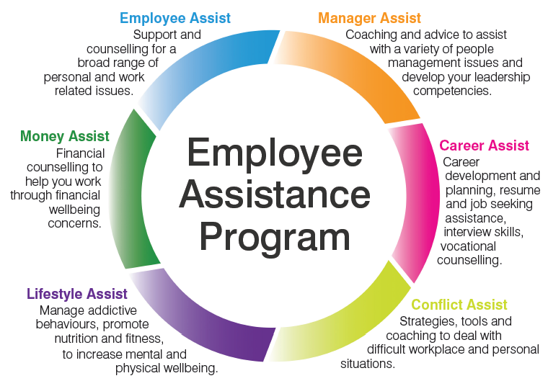
7. Consultation Process
The purpose of the consultation process is to provide affected employees with an opportunity to influence decision makers prior to a proposed change being implemented.
The consultation process occurs as per the process and requirements in the Victorian Mental Health Services Enterprise Agreement 2016 - 2020. An outline and indicative timeframe for this process is included below.
Timeframe and Indicative Dates for Proposed Change

Step | Action | Timeframe
1 | Employer provides change impact statement and other written material required by clause 18.6. Affected Employees and unions consult over change facilitated by the Employer. | Tuesday 24 December 2019
2 | Written response from Employees and/or Union including alternative proposals to mitigate or avert adverse impacts on affected Employees. | 7 days of step 1
3 | Consultation Meeting/s convened | 7 days of step 1
4 | Further Employer written response (where relevant) | By 6 January 2020
5 | Alternative proposal from Employees or Union | By 6 January 2020
6 | If alternate proposal provided, Employer to consider alternative proposal/s consistent with the obligation to consult and arrange further meetings with Employees or Union prior to advising outcome of consultation | By 6 January 2020
7 | Proposed Implementation date | January 13 2020

8. Key Contacts
The below table outlines key contacts in relation to this change. We encourage affected employees to make contact with any of the key contacts listed below to discuss any aspect of this change.
Name | Role | Email | Phone
Andrew Tomlinson | Acting Program Director | A.Tomlinson@mercy.com.au | 9928 7472
Laura Nelson | HR Business Partner | LNelson@mercy.com.au | 8754 3282

Note: The above Change Impact Statement is based on information available at the time of writing and may be subject to change.

